**:-Details of examiner who are paper setter of particular subject.**

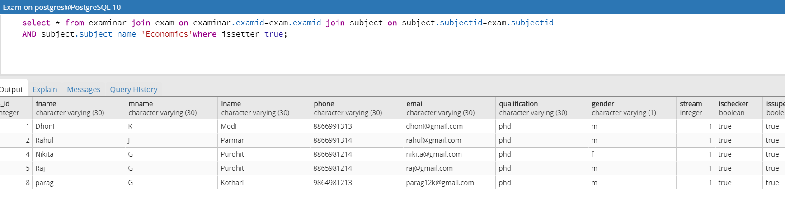

select * from examinar join exam on examinar.examid=exam.examid join subject on subject.subjectid=exam.subjectid

AND subject.subject_name='Economics'where issetter=true;

:-**Details of school where stream are of science**

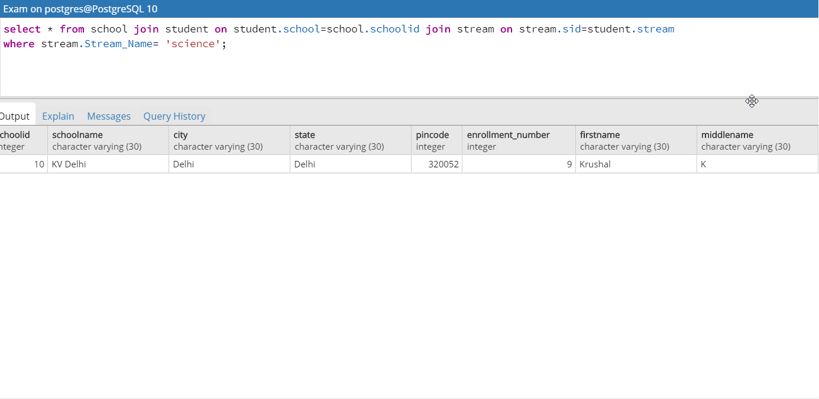

select * from school join student on student.school=school.schoolid join stream on stream.sid=student.stream

where stream.Stream_Name= 'science';

**Details of examiner who are supervisor of particular school:-**

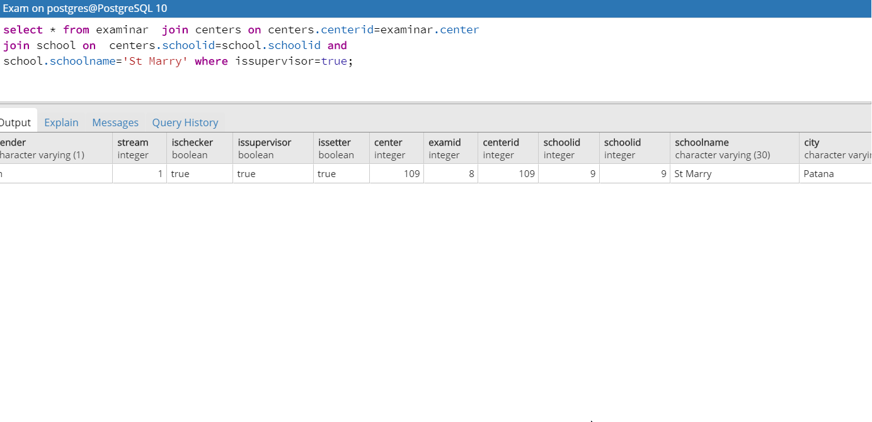

select * from examinar join centers on centers.centerid=examinar.center

join school on centers.schoolid=school.schoolid and

school.schoolname='St Marry' where issupervisor=true;

**:-Count of number of students giving exam who is male and are from commerce field.**

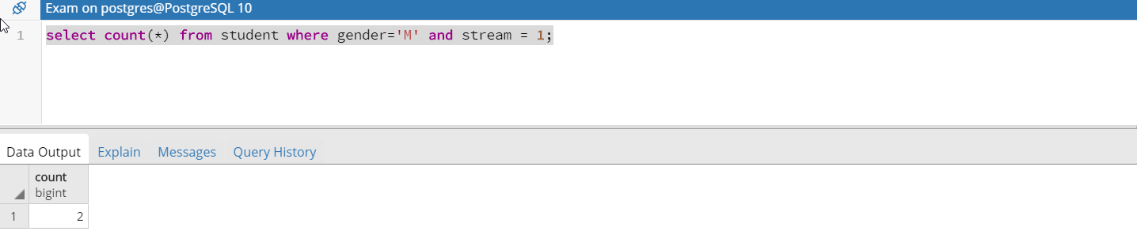

select count(*) from student where gender='M' and stream = 1;

**How many exams conducts at particular center**

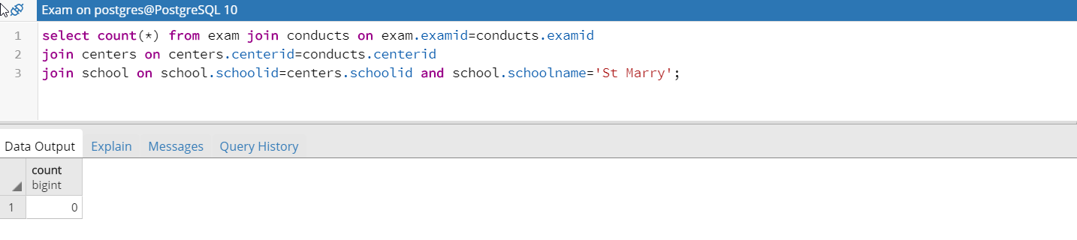

select count(*) from exam join conducts on exam.examid=conducts.examid

join centers on centers.centerid=conducts.centerid

join school on school.schoolid=centers.schoolid and school.schoolname='St Marry';

:- **Schools which are not centers.**

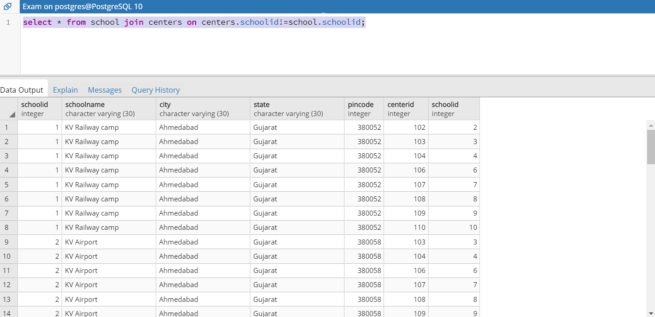

select * from school join centers on centers.schoolid!=school.schoolid;

**Give names of schools in gujarat which are centers.**

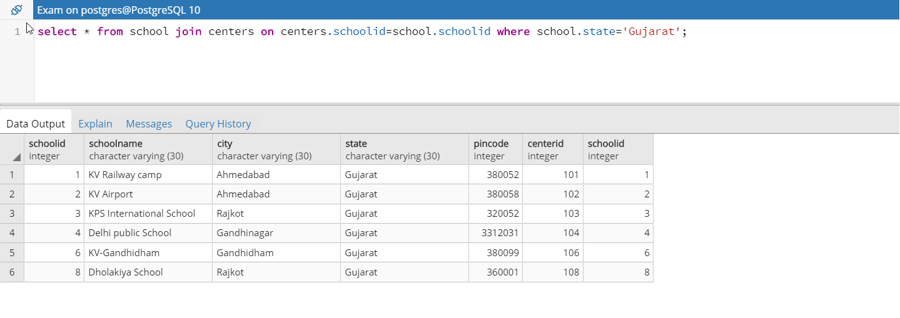

select * from school join centers on centers.schoolid=school.schoolid where school.state='Gujarat';

:- **Number of students who had given re-exam and failed.**

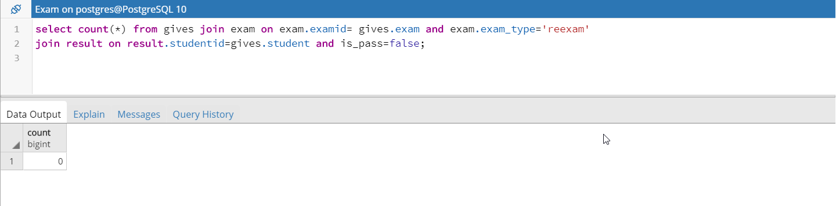

select count(*) from gives join exam on exam.examid= gives.exam and exam.exam_type='reexam'

join result on result.studentid=gives.student and is_pass=false;

**:-How many students failed form commerce stream.**

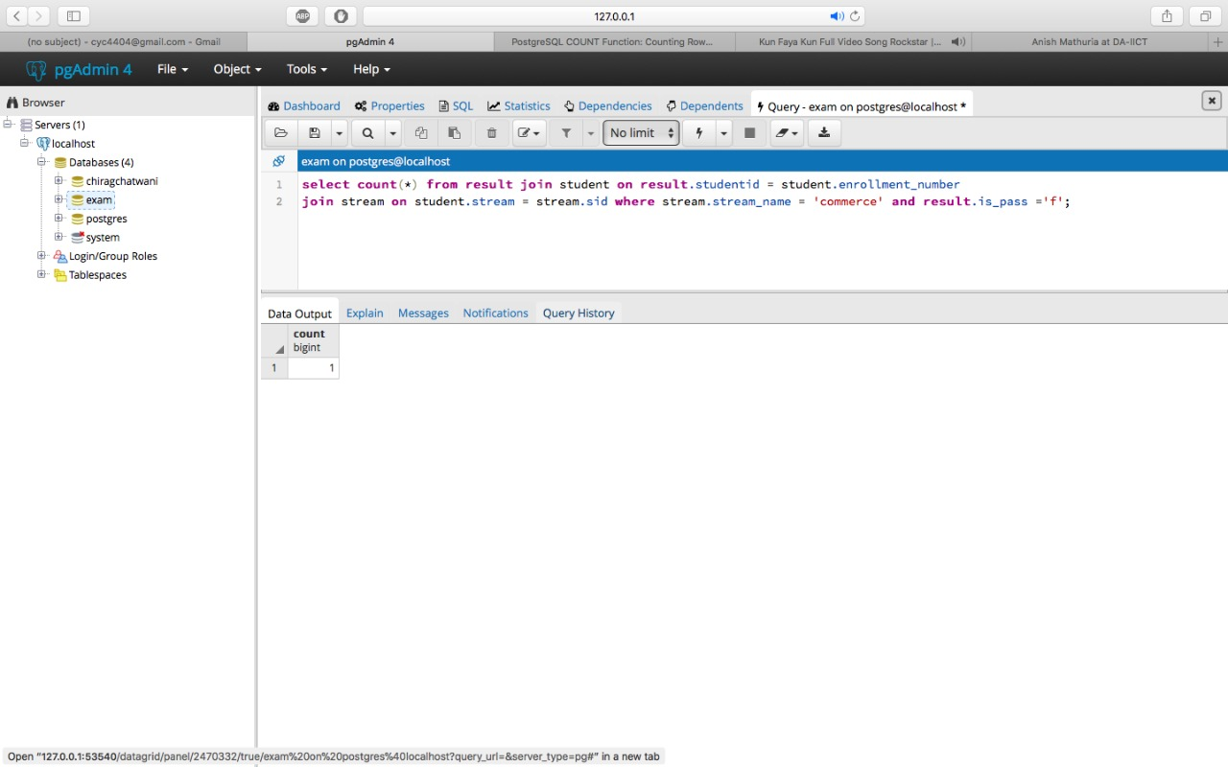

select count(*) from result join student on result.studentid = student.enrollment_number

join stream on student.stream = stream.sid where stream.stream_name = 'commerce' and result.is_pass ='f';

**:-How many students study outside their home town**

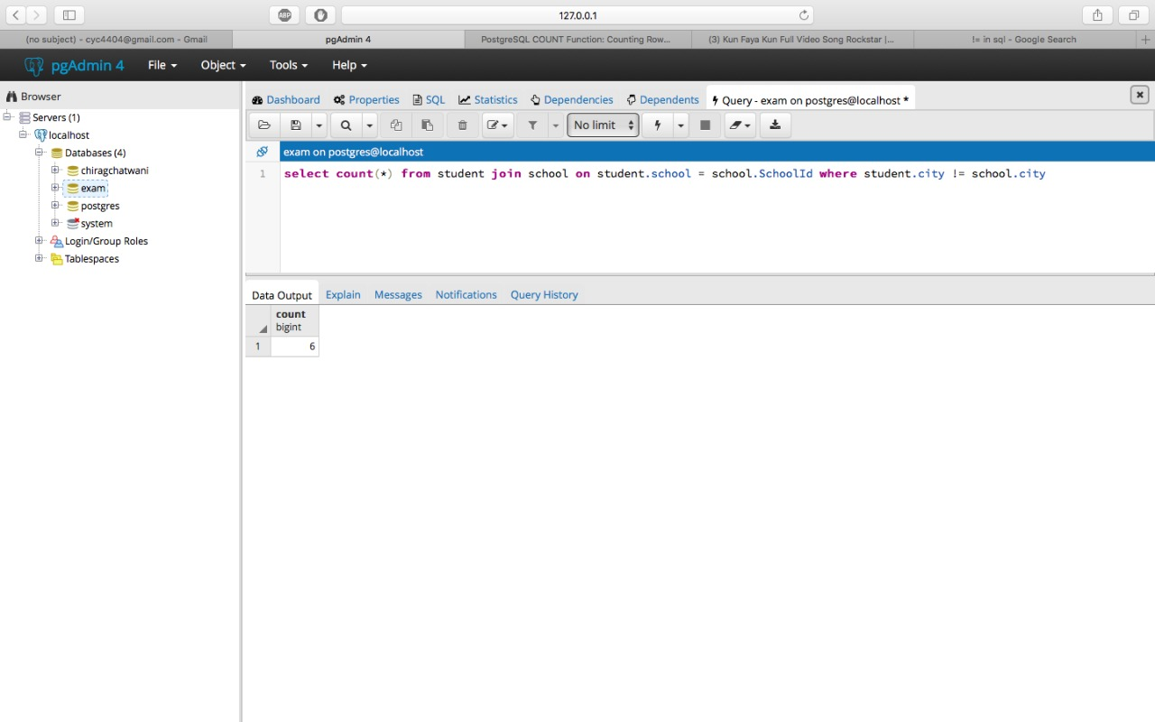

select count(*) from student join school on student.school = school.SchoolId where student.city != school.city

**:-Highest ranking student from particular school**

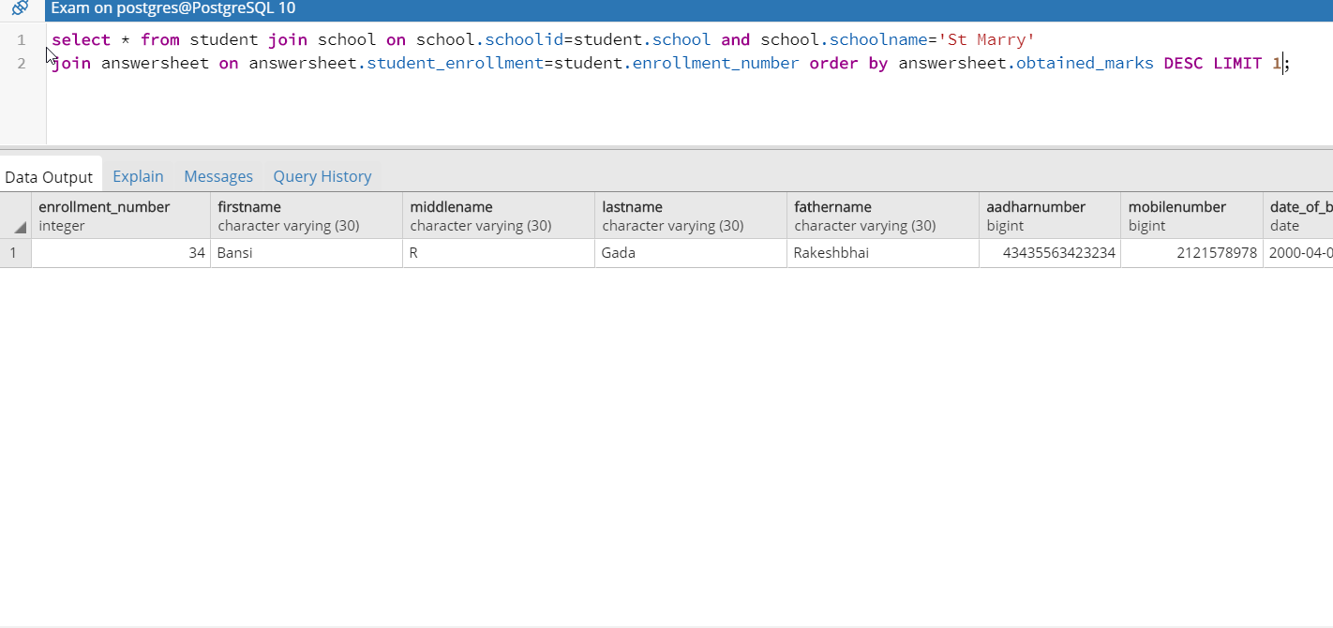



select * from student join school on school.schoolid=student.school and school.schoolname='St Marry'

join answersheet on answersheet.student_enrollment=student.enrollment_number order by answersheet.obtained_marks DESC LIMIT 1;

**:-Student who are absent**

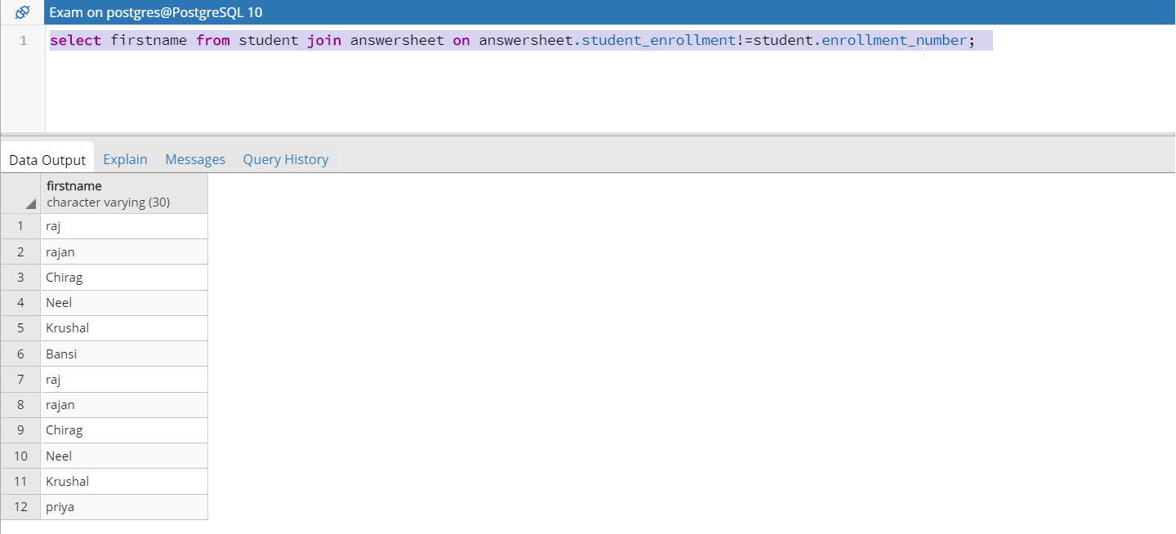

select firstname from student join answersheet on answersheet.student_enrollment!=student.enrollment_number;

**:-How many student can center accommodate**

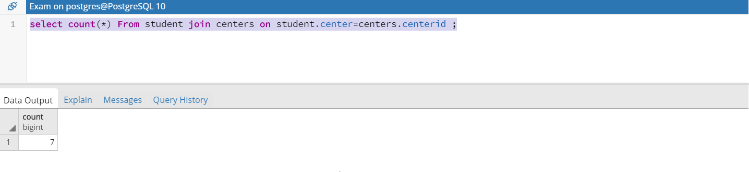

select count(*) From student join centers on student.center=centers.centerid ;